**Library Management Documentation**

**Project Goal**

Create a Library Management System that allows you to add records of Books. You can also add records of Authors, Genres, Locations and assign these to a book through a form.

**Definition of Done / Sprint Goals:**

1. Admin users can View Book records and Edit book records through: Insert/ Update/ Delete
2. Admin users can View Author records and Edit author records through: Insert/ Update/ Delete
3. Admin users can View Genre records and Edit genre records through: Insert/ Update/ Delete
4. Admin users can View Location records and Edit location records through: Insert/ Update/ Delete
5. Admin users can View Books and their associated Genres, Authors, Location.
6. Admin users can Edit Book’s associated Author, Genre records through: Insert/ Update/ Delete

**Sprint Review**

**Done:** Most of the sprint goals were met during the Sprint. The list above was broken down into user stories which had acceptance criteria in the form of Gherkin Syntax for each.

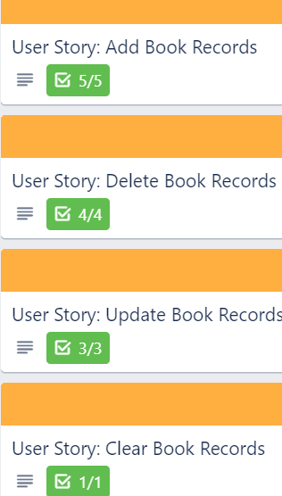 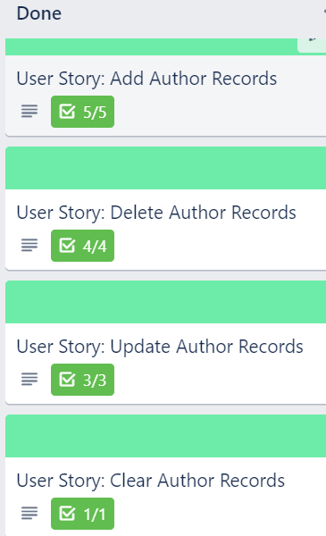 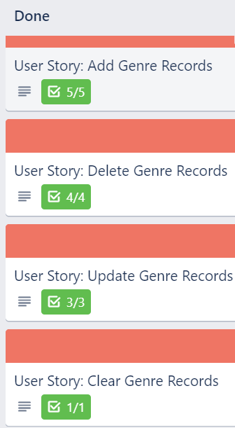 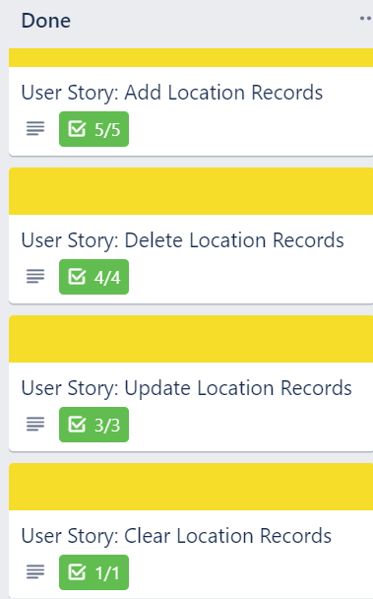 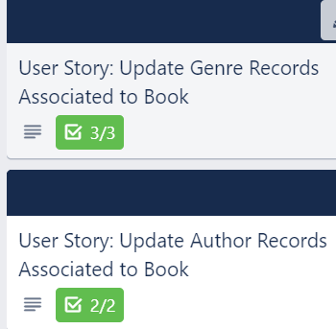

**Actions:** For next time I would like to:

Be able to add/ delete Book-Genre and Author-Book associations from records in the Join tables.

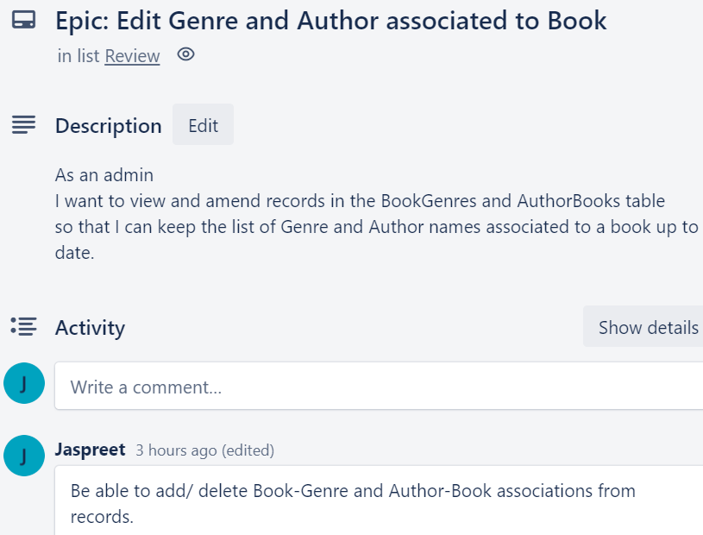

**Sprint retrospective:**

**What went well:**

* I had clear outcomes that I wanted to achieve in terms of the user stories.
* I had an idea of what the user interface would look like and how the user would use it.
* I was able to use join tables to break down the many to many relationship
* I learnt how to use listbox and combo box to render results from the specified tables.

**Improvements:**

* Changes to Records: Remove readonly attribute on Location and set Location as a comboBox with a list of locations.
* Find a better way of updating records on the records page as oppose to having 2 combo boxes for Genres, and 2 for Authors.
* Have a drop down menu instead of buttons across the top of the page, where the user is able to navigate to other pages when the user clicks on the menu. Have an icon for this.
* Setup a login page for the admin where a username and password must be entered in order to access the system. With validations to prevent un-authorised entry.
* Add a scroll if the list of records exceeds the ListBox size.

**Actions:** Work onitem 1 and 2 for the next sprint.

**Overall project retrospective**

I have learned how to:

* integrate the 3 layers together in terms of Business, Data, WPF application.
* create and use join tables to split up a many-to-many relationship.
* render data from the table in a list box and a combo box.

Next time I would:

* check tests against the WPF application a lot sooner.
* have clearly defined acceptance criteria at the beginning so I know exactly the goals I need to meet
* focus a bit more on the user interface design so it is a bit more user-friendly

**Class Diagram**

This is called ClassDiagram.cs and is present in the LibraryData folder. I was not able to add the associations on the diagram but I have so on the screenshot below.

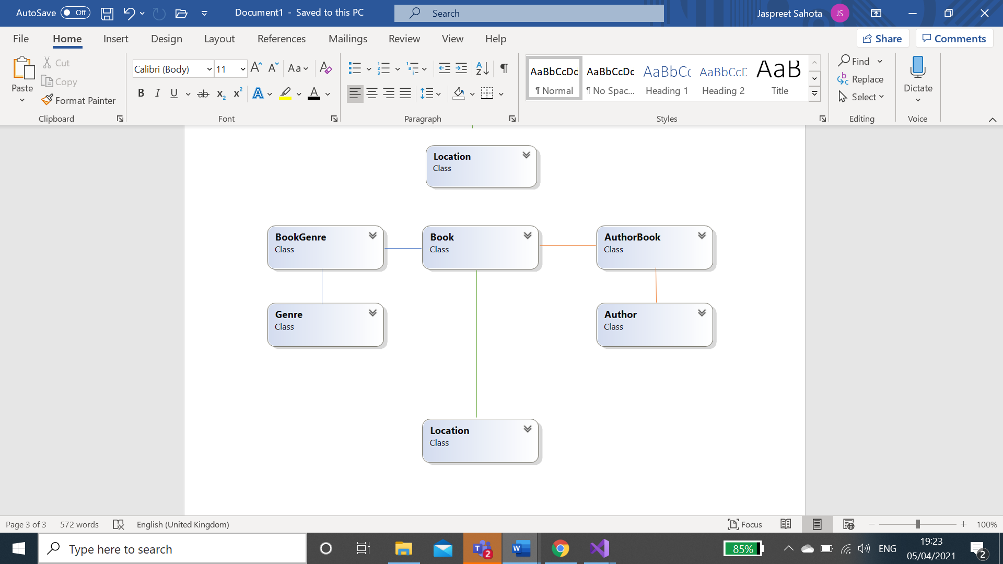

1

1

1

1

1

M

M

M

M

**User guide**

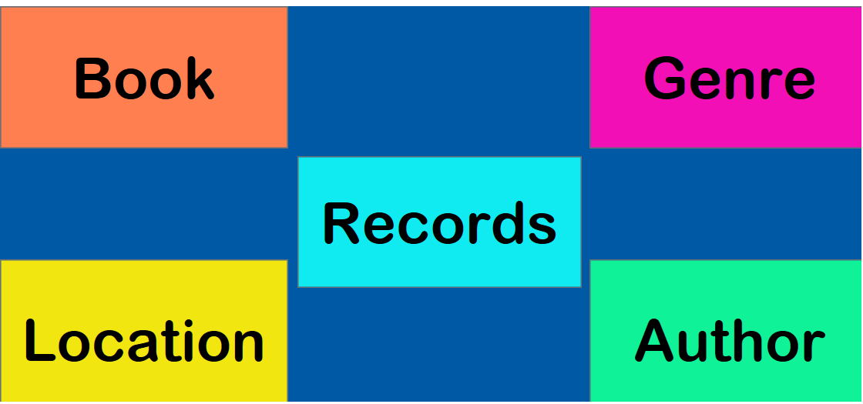

Navigate to different pages by clicking on the coloured buttons.

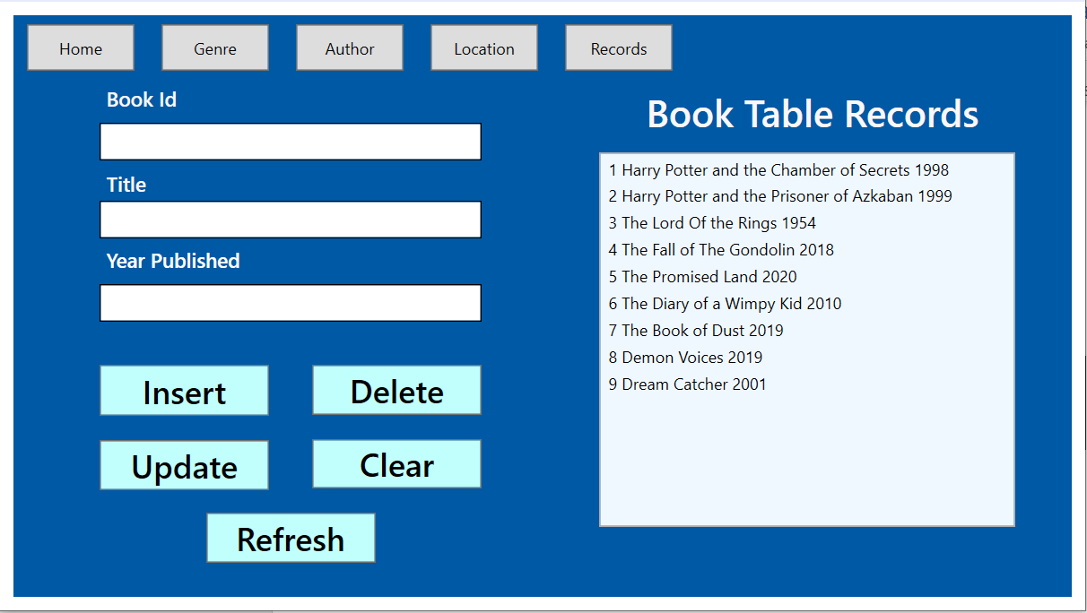

Navigate to different pages by clicking on the buttons along the top.

Update/ Delete record by selecting on the record and selecting Update/ Delete.

To add a new record click Insert. Fill in the form, save the changes and click Refresh to see the record added.

When record is selected if you want to clear fields press clear.

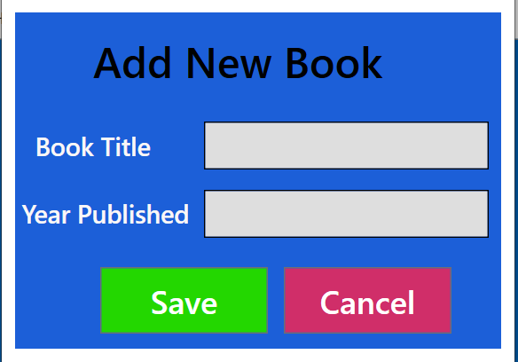

When Insert is clicked this form window opens where you can enter title and year published detail about the book. If field is not filled you will be notified with message pop up box, when you click save. If both fields are filled, the record will be inserted. Clicking cancel will redirect you back to the previous window.

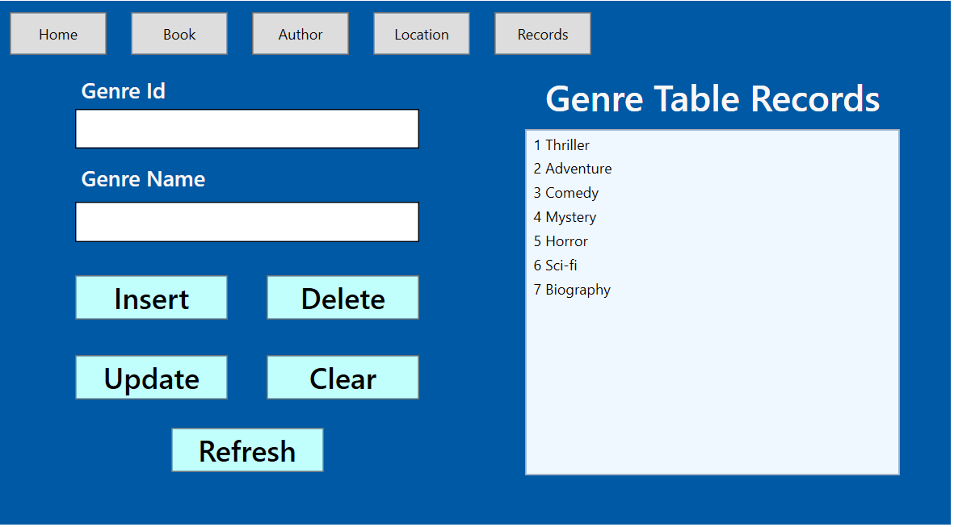

Other pages have similar layout and functionality, so it is easy to navigate around. When updating/ delete records the Id field is set to read only so it cannot be edited.

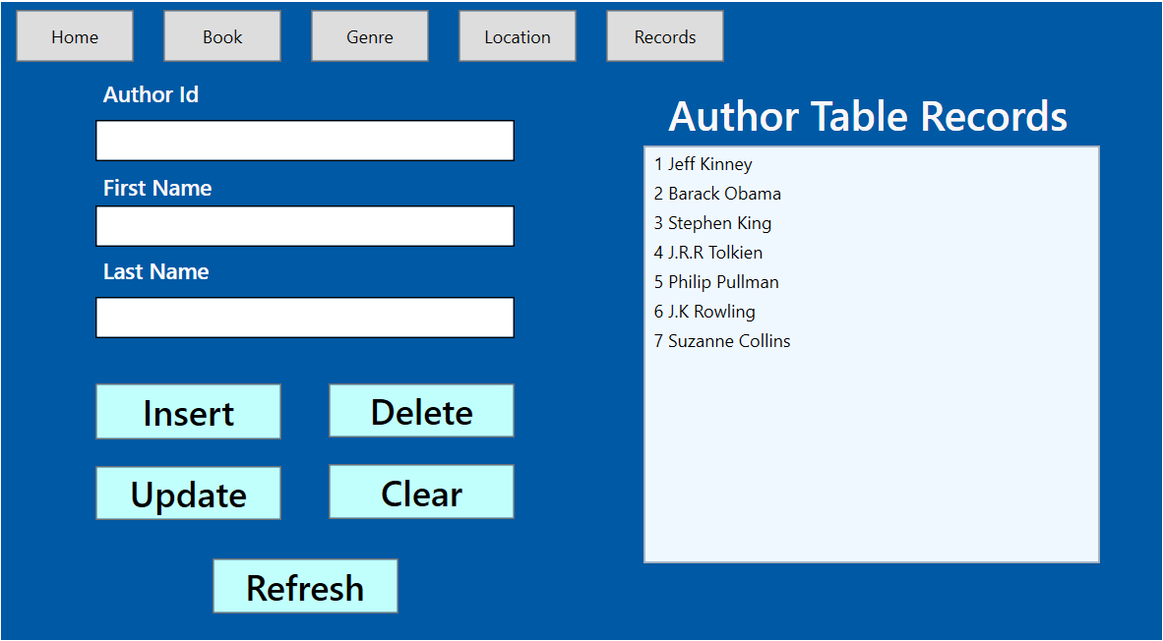 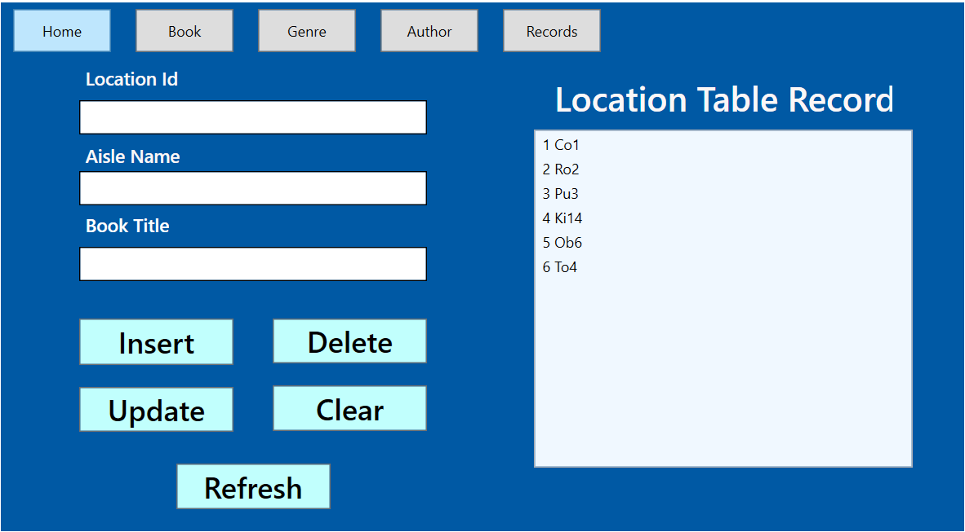

In the Location Page both the Id and Book Title are read only fields as the user is only allowed to change the location of a given book.

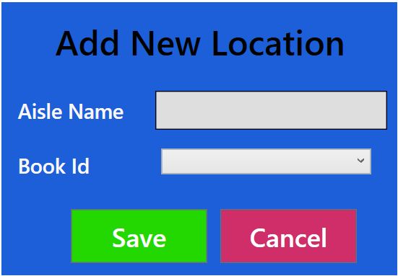

If the user wants to add a new location then they are able to enter this in the Aisle Name field, whereas for the Book Id you can select it from the drop down list.

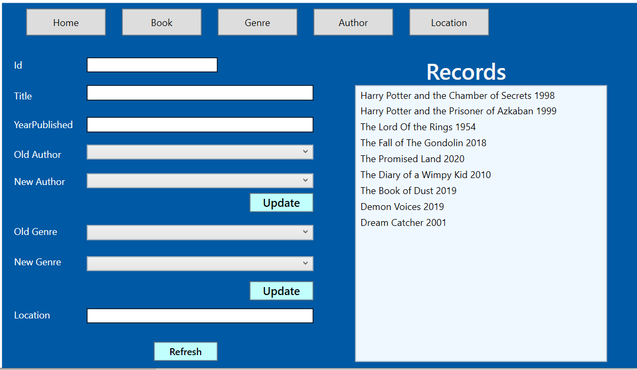

In the Records tab you are able to select a record, which will populate the fields. To change the Author/ Genre associated to a Book you can select the old Author from a list of associated orders. Then you can select the new Author you want to change it to, click update, followed by Refresh. When you reselect the record you will see this updated author/ genre in the old author/ old genre list.